- B. Experiment
Steps:
- Press Windows +R, type cmd and enter.
- Create Folders.
- cd Desktop
- mkdir fsd2
- cd fsd2
- mkdir my_app
- cd my_app
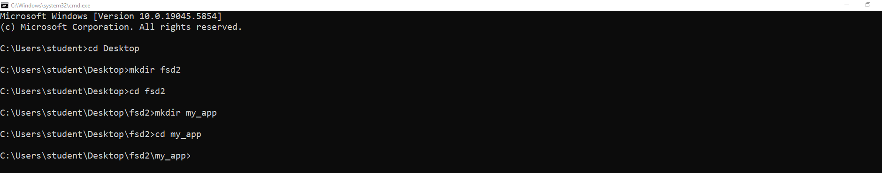
- Create a React App
npx create-react-app react-lab
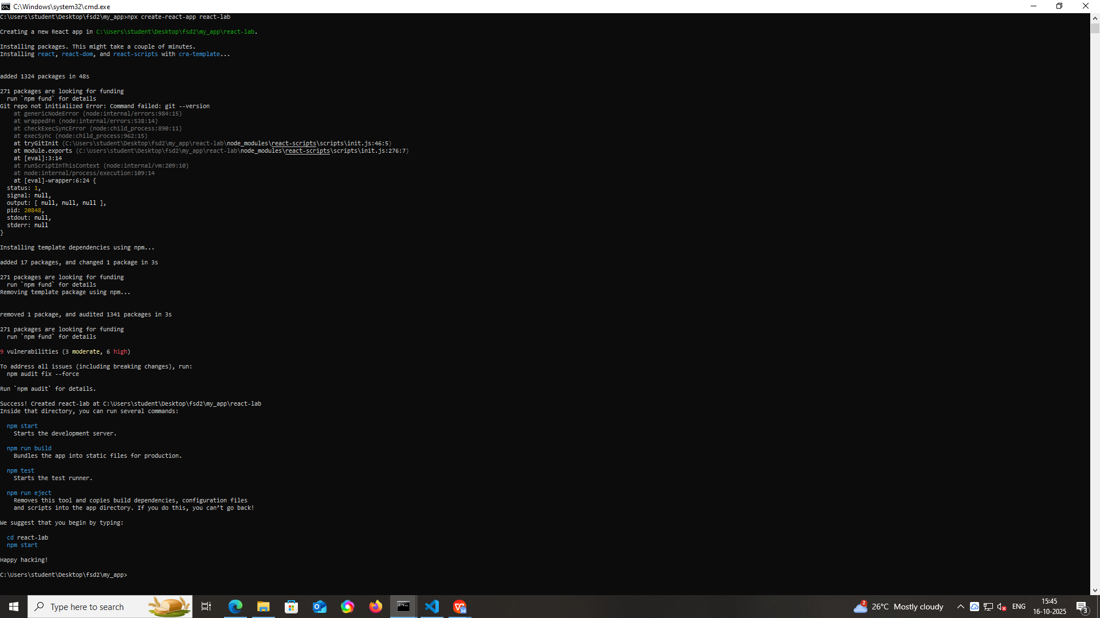
* This will take a few minutes to download and set up the boilerplate React files. If it says “npx not recognized”, install Node.js from https://nodejs.org and reopen CMD.
If any path error Getting
mkdir <copy and paste path showing in error > (example: C:\Users\TEMP\AppData\Roaming\npm)
Then again type the following command
npx create-react-app react-lab
- Navigate into the Project Folder
cd react-lab
Now your full path will look like:
C:\Users\student\Desktop\FSD2\my_app\react-lab
- Open the Folder in VS Code
code .
* This opens your current folder as a VS Code workspace.
* If this doesn’t work, you may need to enable the “Add to PATH” option in VS Code setup or open VS Code manually and use File → Open Folder → navigate to react-lab.
- Open the integrated terminal in VS Code ( Click on three dots - Terminal- New Terminal) and check the current path in terminal (C:\Users\student\Desktop\FSD2\my_app\react-lab)
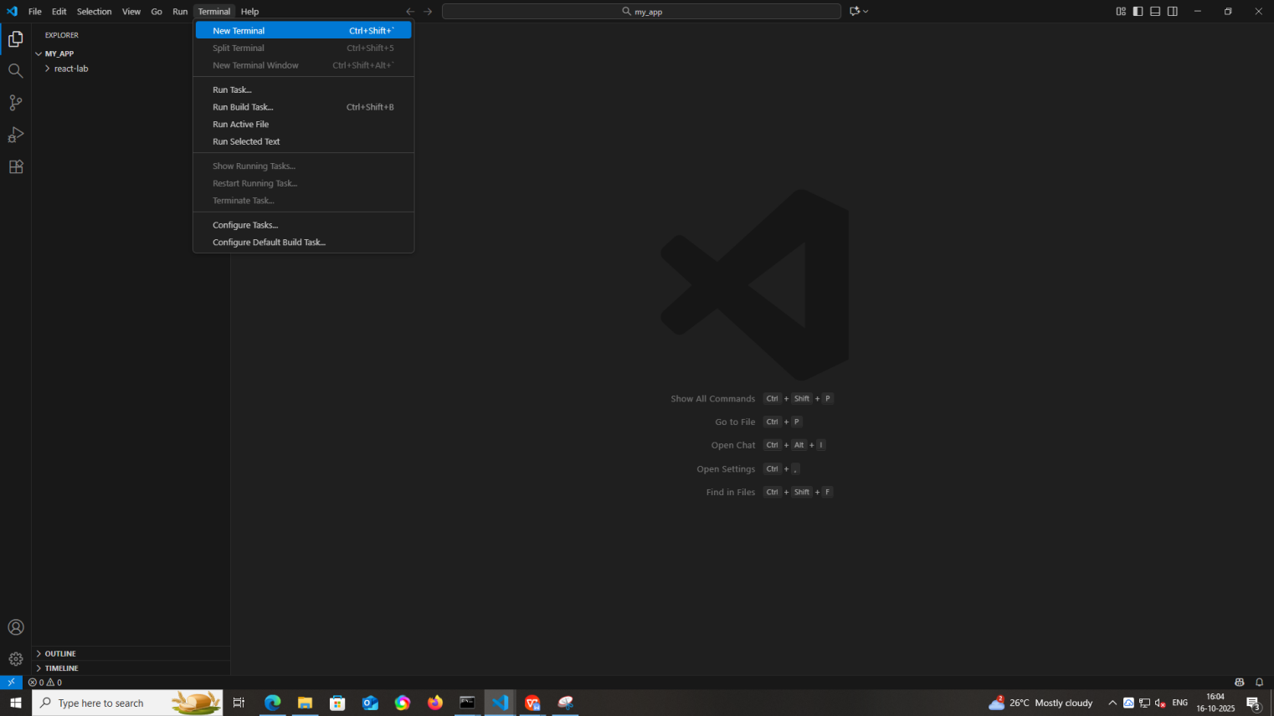
and then type the following command.
npm start
It will start the server in local host URL in your web browser (example: http://localhost:3001/ ).
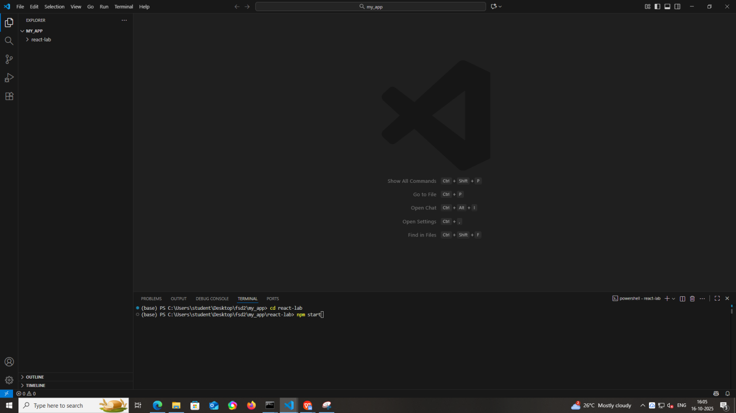
- Split the terminals then type the following command to install required DOM packages.
npm install react react-dom react-router-dom
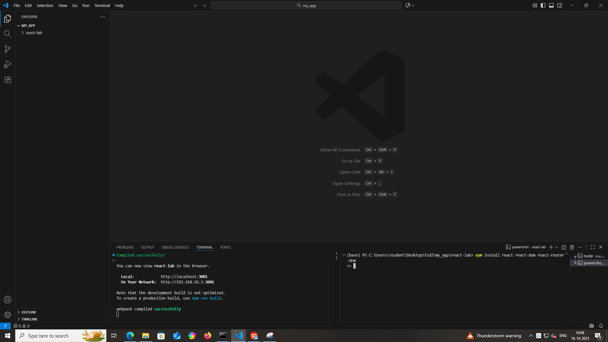
Also check the list of DOM versions downloaded properly or not
npm list react react-dom react-router-dom

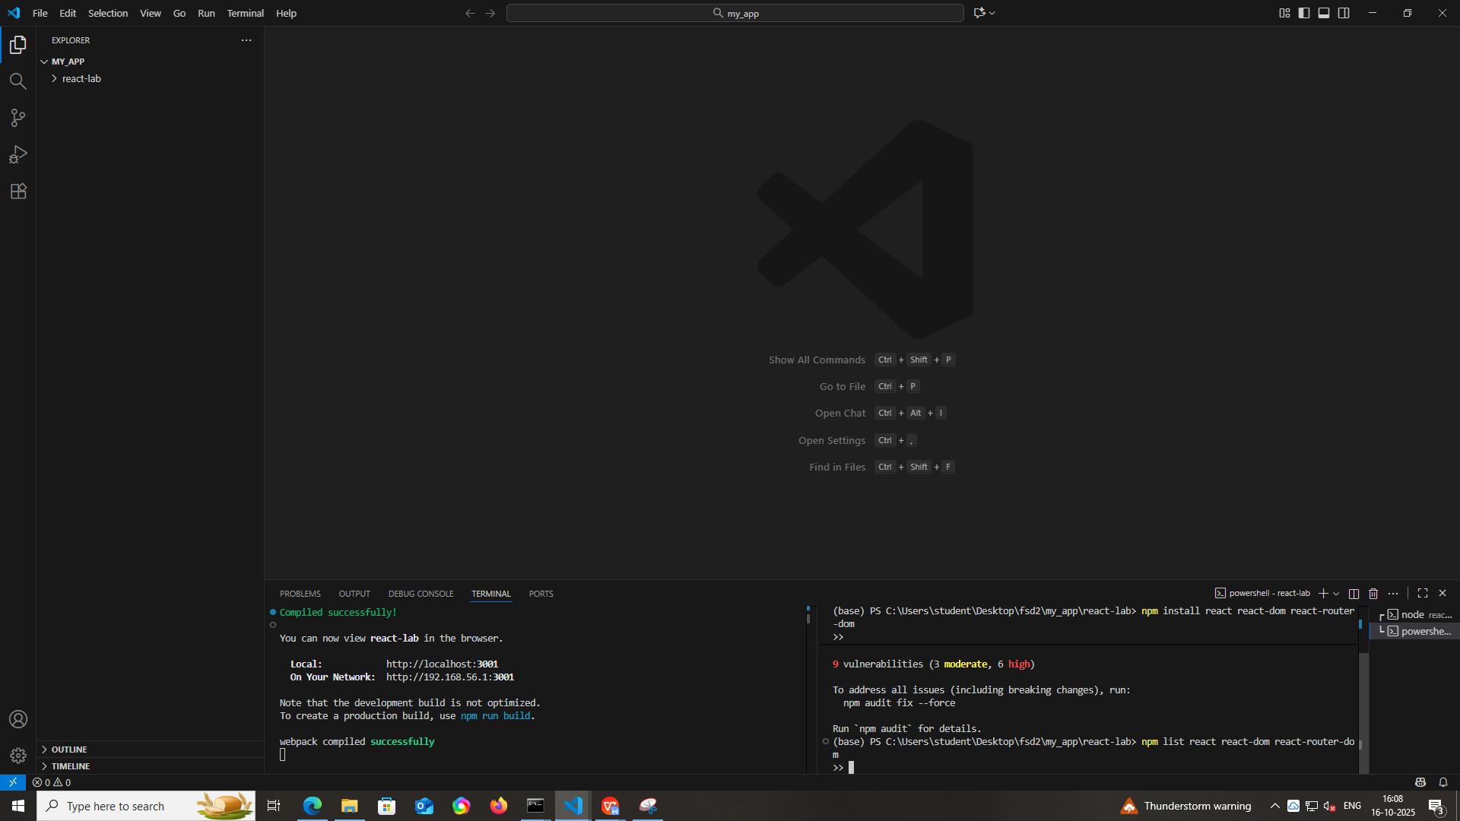
It will give you output something like this
react-lab@0.1.0 C:\Users\student\Desktop\fsd2\my_app\react-lab
├─┬ @testing-library/react@16.3.0
│ ├── react-dom@19.2.0 deduped
│ └── react@19.2.0 deduped
├─┬ react-dom@19.2.0
│ └── react@19.2.0 deduped
├─┬ react-router-dom@7.9.4
│ ├── react-dom@19.2.0 deduped
│ ├─┬ react-router@7.9.4
│ │ ├── react-dom@19.2.0 deduped
│ │ └── react@19.2.0 deduped
│ └── react@19.2.0 deduped
├─┬ react-scripts@5.0.1
│ └── react@19.2.0 deduped
└── react@19.2.0
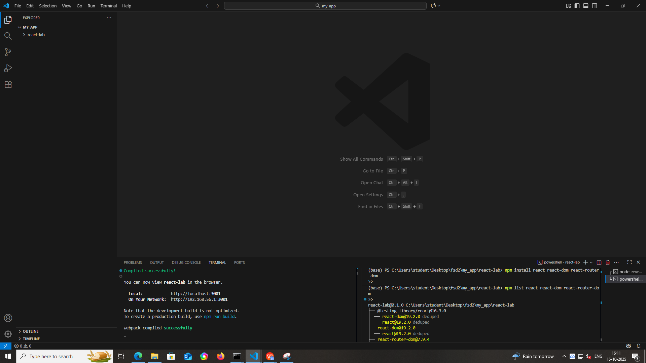
- Confirm packages are listed in package.json
Open package.json file and check all dependencies are installed properly or not.
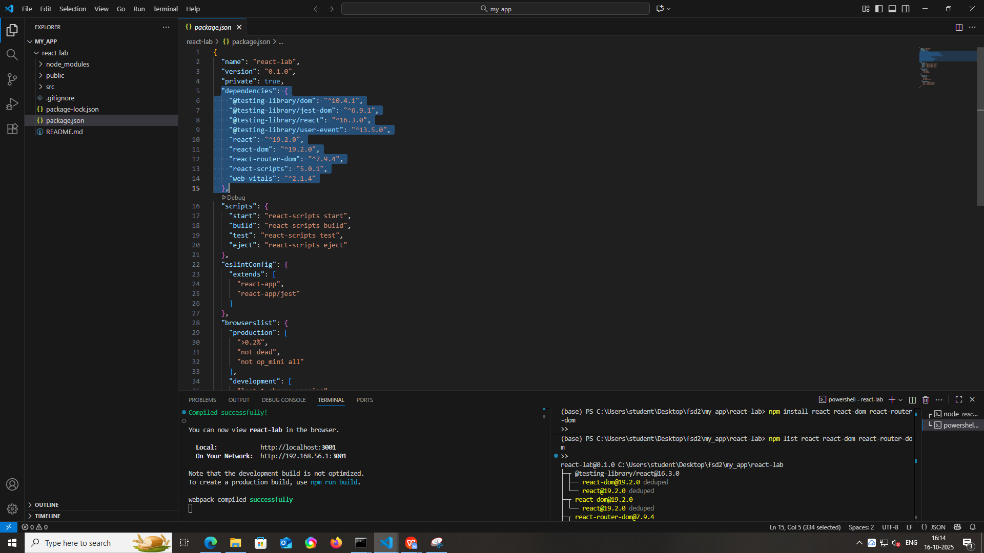
- Create pages Folder Structure through VS code
* open react-lab then click on src and top right side click on new folder then create pages.
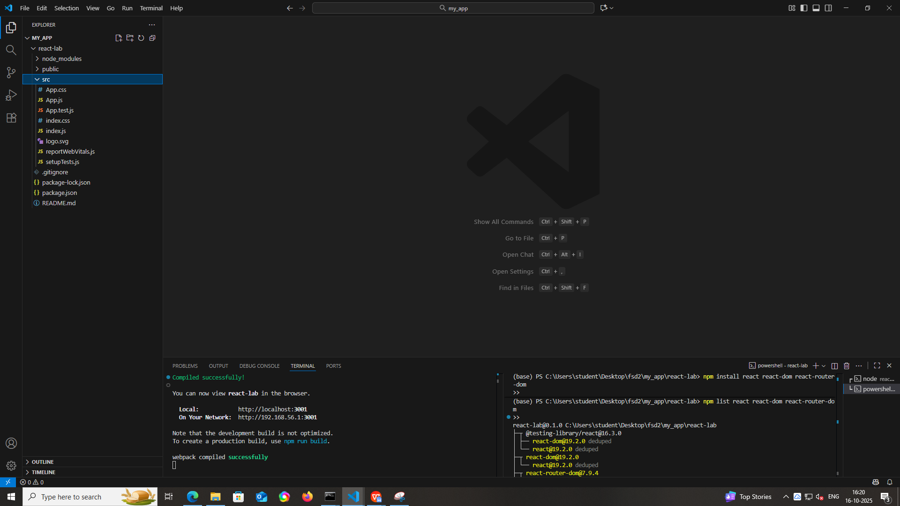
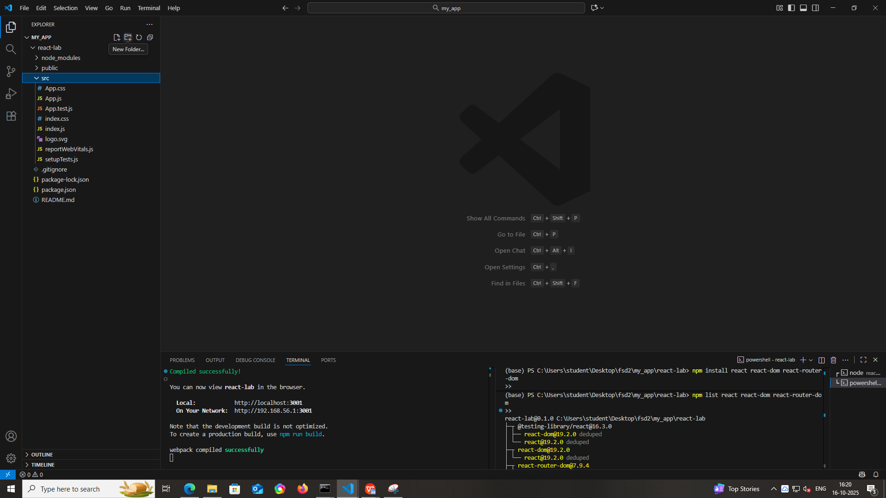
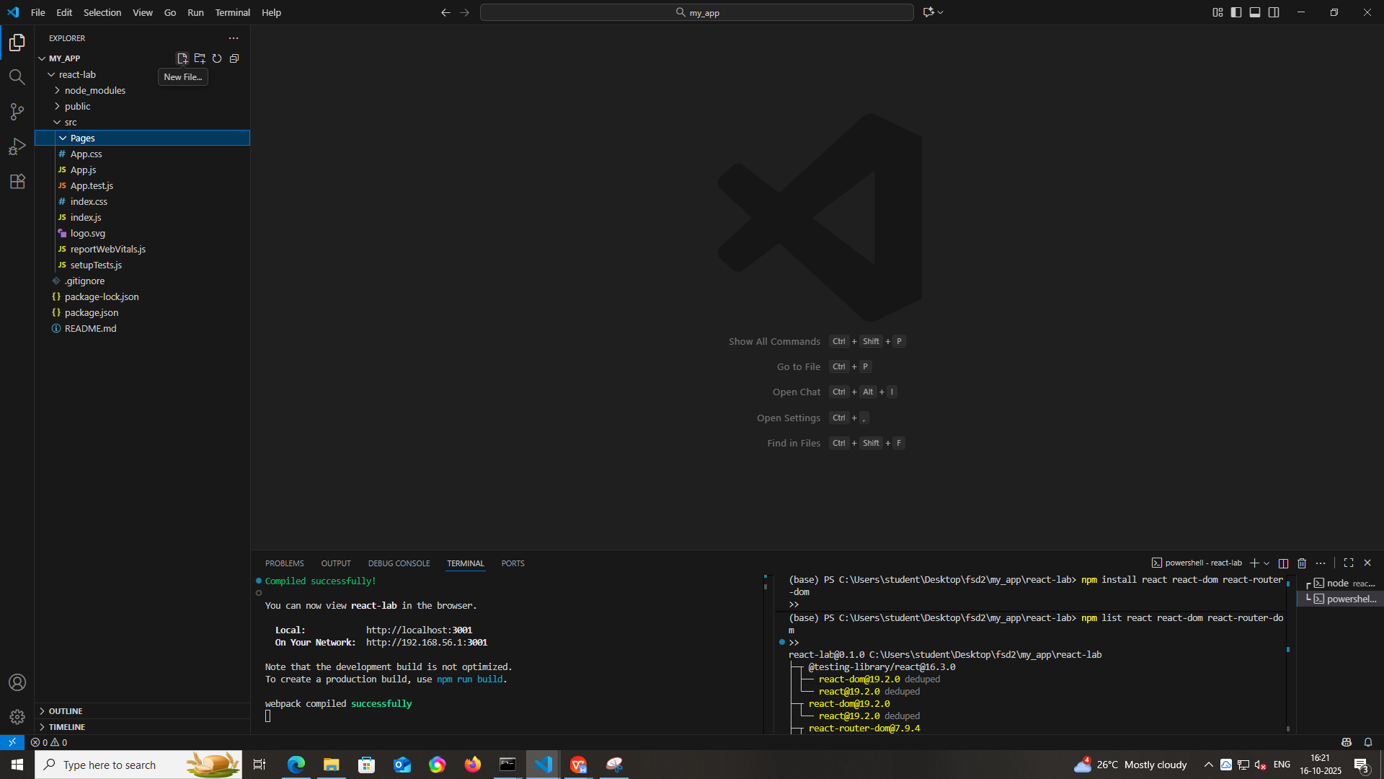
* Then click on that pages folder and top right side click on new file and then create Home.js, About.js, Contact.js files
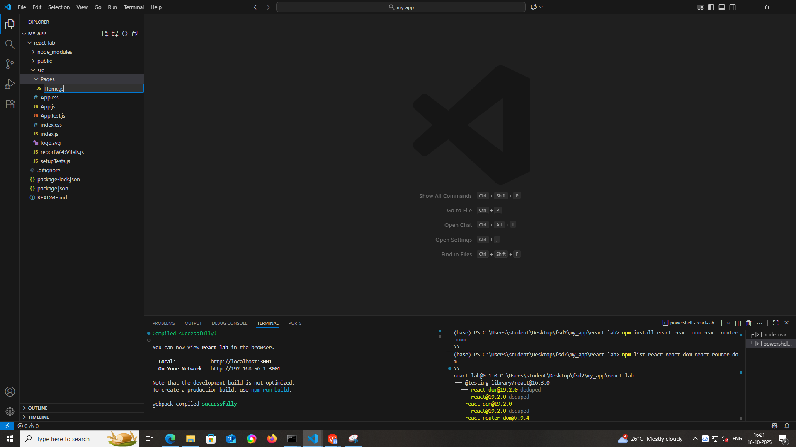

- Now after creating all files edit the files with the following codes.
Home.js
import React from "react";

export default function Home() {
return (
<div style={{ textAlign: "center" }}>
<h1 style={{ color: "#282c34" }}>Welcome to React Lab</h1>
<p style={{ fontSize: "18px", color: "#555" }}>
This is a small, beautiful website template with Home, About, and Contact pages.
</p>
<img
src="https://images.unsplash.com/photo-1507525428034-b723cf961d3e?auto=format&fit=crop&w=600&q=80"
alt="Decorative"
style={{ borderRadius: "10px", marginTop: "20px", maxWidth: "100%", height: "auto" }}
/>
</div>
);
}

About.js
import React from "react";

export default function About() {
return (
<div>
<h1 style={{ color: "#282c34", textAlign: "center" }}>About Us</h1>
<p style={{ fontSize: "18px", color: "#555", lineHeight: "1.6" }}>
This website is a React-based template for small projects. It demonstrates:
</p>
<ul style={{ fontSize: "18px", color: "#555", marginLeft: "20px" }}>
<li>React Router for multiple pages</li>
<li>Simple navigation bar with active link styling</li>
<li>Responsive and clean design with modern colors</li>
</ul>
</div>
);
}

Contact.js
import React from "react";

export default function Contact() {
return (
<div style={{ textAlign: "center" }}>
<h1 style={{ color: "#282c34" }}>Contact Us</h1>
<p style={{ fontSize: "18px", color: "#555" }}>
Email: example@reactlab.com <br />
Phone: +91 90000 00000
</p>
<form style={{ marginTop: "20px", maxWidth: "400px", margin: "auto" }}>
<input
type="text"
placeholder="Your Name"
style={{ width: "100%", padding: "10px", marginBottom: "10px", borderRadius: "5px", border: "1px solid #ccc" }}
/>
<input
type="email"
placeholder="Your Email"
style={{ width: "100%", padding: "10px", marginBottom: "10px", borderRadius: "5px", border: "1px solid #ccc" }}
/>
<textarea
placeholder="Message"
rows="4"
style={{ width: "100%", padding: "10px", borderRadius: "5px", border: "1px solid #ccc" }}
></textarea>
<button
type="submit"
style={{ marginTop: "10px", padding: "10px 20px", background: "#61dafb", border: "none", borderRadius: "5px", cursor: "pointer" }}
>
Send
</button>
</form>
</div>
);
}

Index.js
import React from 'react';
import ReactDOM from 'react-dom/client';
import './index.css';
import App from './App';
import reportWebVitals from './reportWebVitals';
import { BrowserRouter } from 'react-router-dom'; // ✅ Added for routing

const root = ReactDOM.createRoot(document.getElementById('root'));
root.render(
<React.StrictMode>
<BrowserRouter> {/* ✅ Wrap App for routing */}
<App />
</BrowserRouter>
</React.StrictMode>
);

reportWebVitals();

App.js
import React from "react";
import { Routes, Route, NavLink } from "react-router-dom";
import Home from "./Pages/Home";
import About from "./Pages/About";
import Contact from "./Pages/Contact";

const navStyle = {
display: "flex",
justifyContent: "center",
gap: "30px",
padding: "20px",
background: "#282c34",
};

const linkStyle = {
color: "white",
textDecoration: "none",
fontWeight: "bold",
};

const activeLinkStyle = {
color: "#61dafb",
};

export default function App() {
return (
<div style={{ fontFamily: "Arial, sans-serif", minHeight: "100vh", background: "#f5f5f5" }}>
<nav style={navStyle}>
<NavLink to="/" style={linkStyle} end activeStyle={activeLinkStyle}>
Home
</NavLink>
<NavLink to="/about" style={linkStyle} activeStyle={activeLinkStyle}>
About
</NavLink>
<NavLink to="/contact" style={linkStyle} activeStyle={activeLinkStyle}>
Contact
</NavLink>
</nav>
<div style={{ padding: "40px", maxWidth: "800px", margin: "auto" }}>
<Routes>
<Route path="/" element={<Home />} />
<Route path="/about" element={<About />} />
<Route path="/contact" element={<Contact />} />
</Routes>
</div>
</div>
);
}

- After Executing editing all above you will get the following outputs
